General Cylindrical Surface
# Source: AI Source: Provided by: [Data Path: Persons Table -> ID Column: 1, Name_En Column: Motasem Essam] -> From: [ChatGPT] on [7/20/2026]
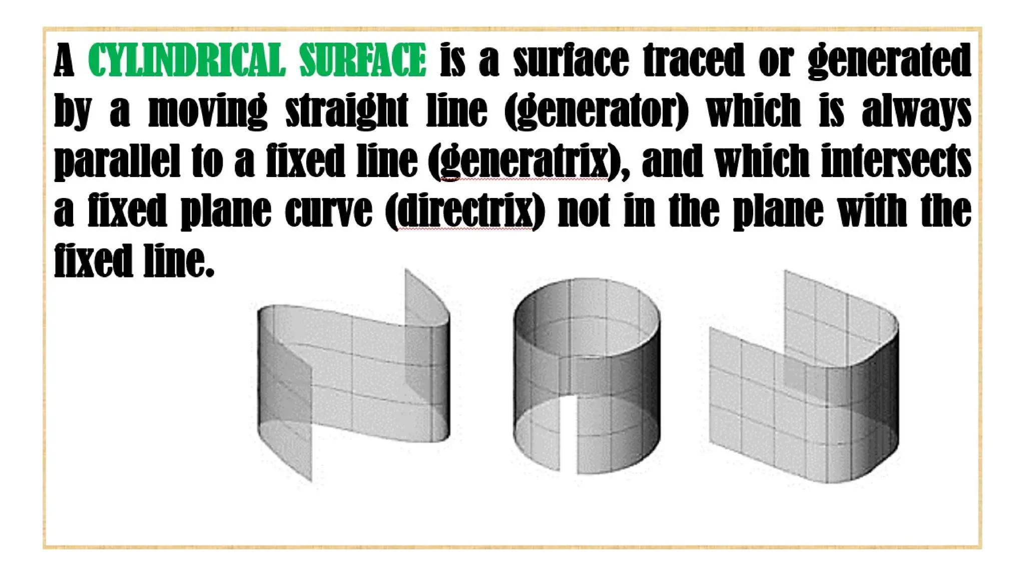
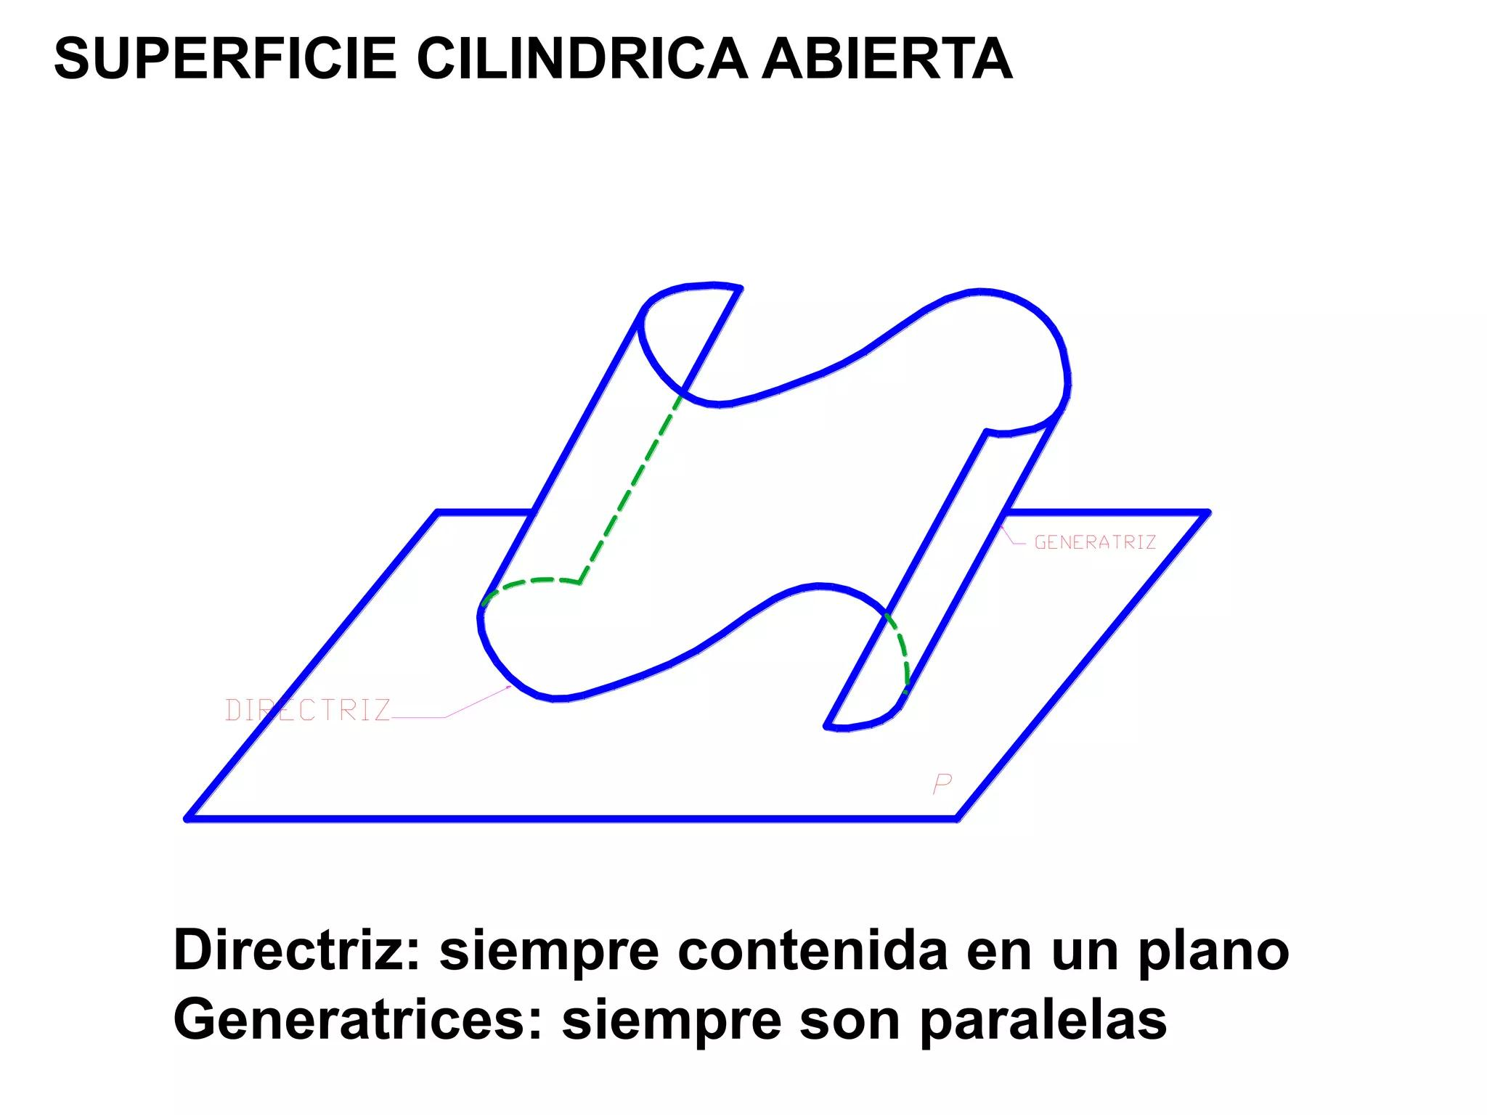
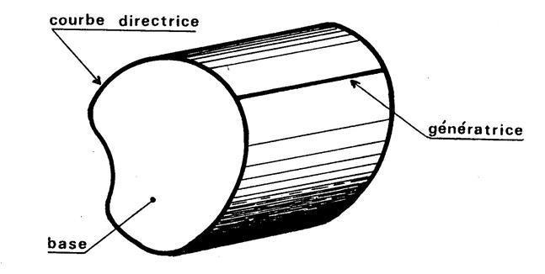
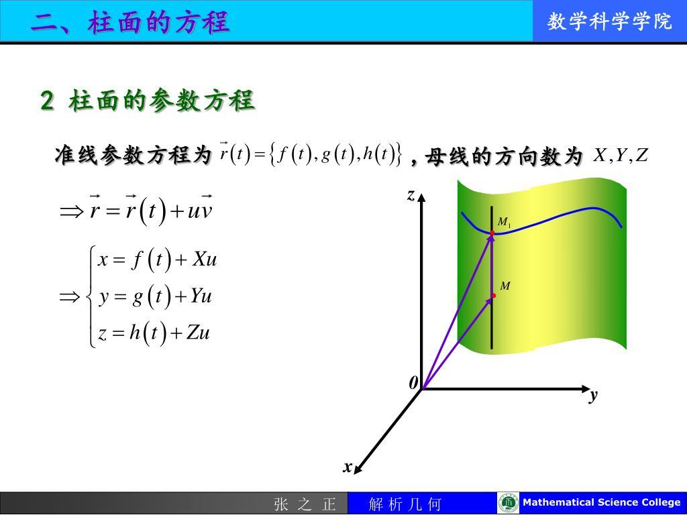

Definition
# Source: AI Source: Provided by: [Data Path: Persons Table -> ID Column: 1, Name_En Column: Motasem Essam] -> From: [ChatGPT] on [7/20/2026]
A General Cylindrical Surface is a curved surface generated by a straight line, called a generator, that moves parallel to a fixed direction while passing through or following a fixed curve called the directrix.
Unlike a Circular Cylindrical Surface, whose directrix is a circle, a general cylindrical surface may have any suitable plane curve as its directrix.
In simple terms:
A general cylindrical surface is formed by extending a curve in a fixed direction using parallel straight lines.
For example, if a circle is extended in a direction perpendicular to its plane, a circular cylindrical surface is produced. If a different curve is extended, a different cylindrical surface is produced.

Purpose
# Source: AI Source: Provided by: [Data Path: Persons Table -> ID Column: 1, Name_En Column: Motasem Essam] -> From: [ChatGPT] on [7/20/2026]
A general cylindrical surface is used to:
- Represent cylindrical surfaces whose cross-section is not necessarily circular.
- Generalize ordinary cylinders beyond circular cylinders.
- Model surfaces generated by translating a curve along a fixed direction.
- Describe many surfaces in analytic geometry and calculus.
- Model structures with constant cross-sectional shapes.
- Provide a general framework for circular, elliptical, parabolic, and other cylindrical surfaces.

Fundamental Elements
# Source: AI Source: Provided by: [Data Path: Persons Table -> ID Column: 1, Name_En Column: Motasem Essam] -> From: [ChatGPT] on [7/20/2026]
A general cylindrical surface has several important elements.

1. Directrix
# Source: AI Source: Provided by: [Data Path: Persons Table -> ID Column: 1, Name_En Column: Motasem Essam] -> From: [ChatGPT] on [7/20/2026]
The directrix is the fixed curve that determines the shape of the cylindrical surface.
Examples include:
- Circle
- Ellipse
- Parabola
- Hyperbola
- Other suitable plane curves

2. Generator
# Source: AI Source: Provided by: [Data Path: Persons Table -> ID Column: 1, Name_En Column: Motasem Essam] -> From: [ChatGPT] on [7/20/2026]
A generator is a straight line that forms part of the cylindrical surface.
All generators of a cylindrical surface are parallel to one another.

3. Direction of Generation
# Source: AI Source: Provided by: [Data Path: Persons Table -> ID Column: 1, Name_En Column: Motasem Essam] -> From: [ChatGPT] on [7/20/2026]
The generators move in a fixed direction.
The direction does not have to be perpendicular to the plane containing the directrix.

4. Cross-Section
# Source: AI Source: Provided by: [Data Path: Persons Table -> ID Column: 1, Name_En Column: Motasem Essam] -> From: [ChatGPT] on [7/20/2026]
A cross-section perpendicular to the generators reproduces the shape of the directrix.
For example:
- Circular directrix → circular cylindrical surface
- Elliptical directrix → elliptical cylindrical surface
- Parabolic directrix → parabolic cylindrical surface

5. Axis
# Source: AI Source: Provided by: [Data Path: Persons Table -> ID Column: 1, Name_En Column: Motasem Essam] -> From: [ChatGPT] on [7/20/2026]
A general cylindrical surface does not necessarily have a conventional axis like a circular cylinder.
An axis is naturally defined for highly symmetric cases, particularly circular cylindrical surfaces.

General Geometric Construction
# Source: AI Source: Provided by: [Data Path: Persons Table -> ID Column: 1, Name_En Column: Motasem Essam] -> From: [ChatGPT] on [7/20/2026]
Suppose a curve $C$lies in a plane.
If every point of $C$is extended along the same direction by parallel straight lines, the resulting collection of lines forms a cylindrical surface.
Conceptually:
$$\text{Directrix}+\text{Parallel Generators}⟶\text{Cylindrical Surface}$$
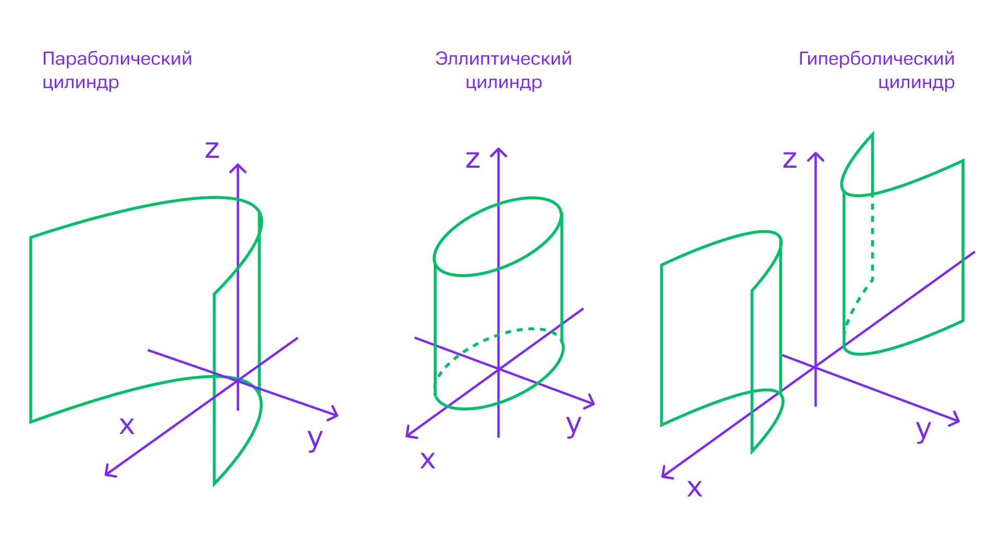
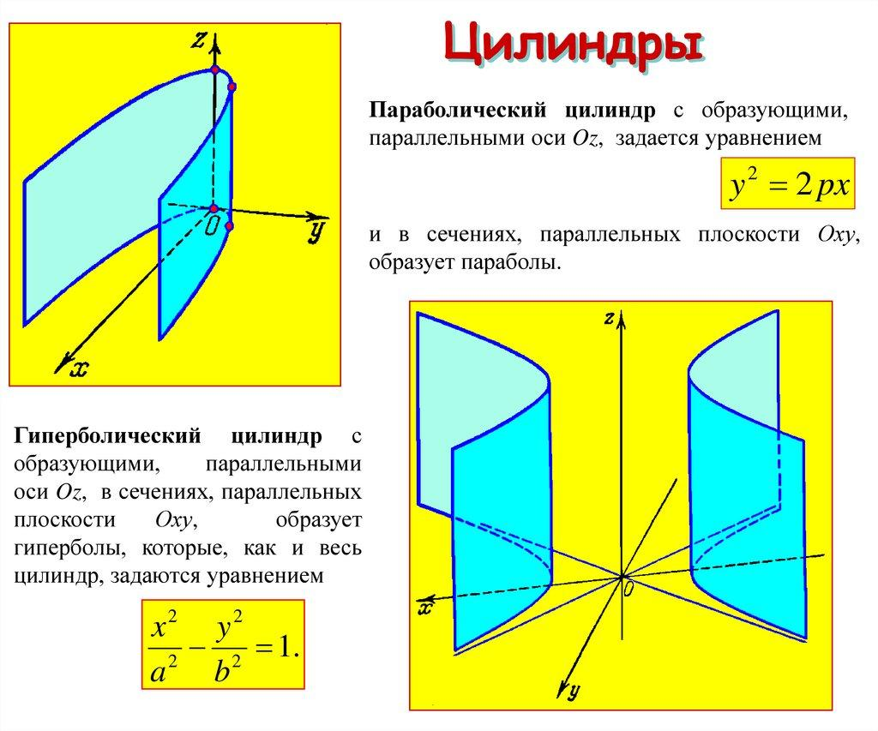
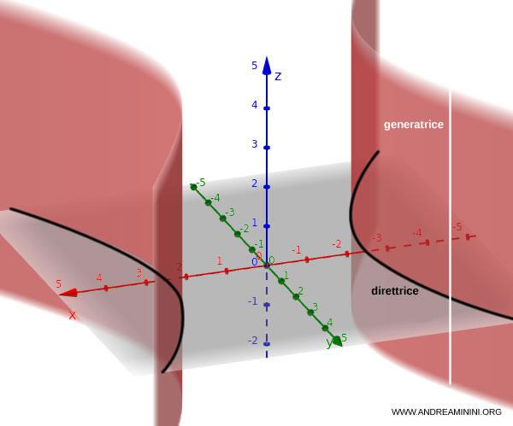
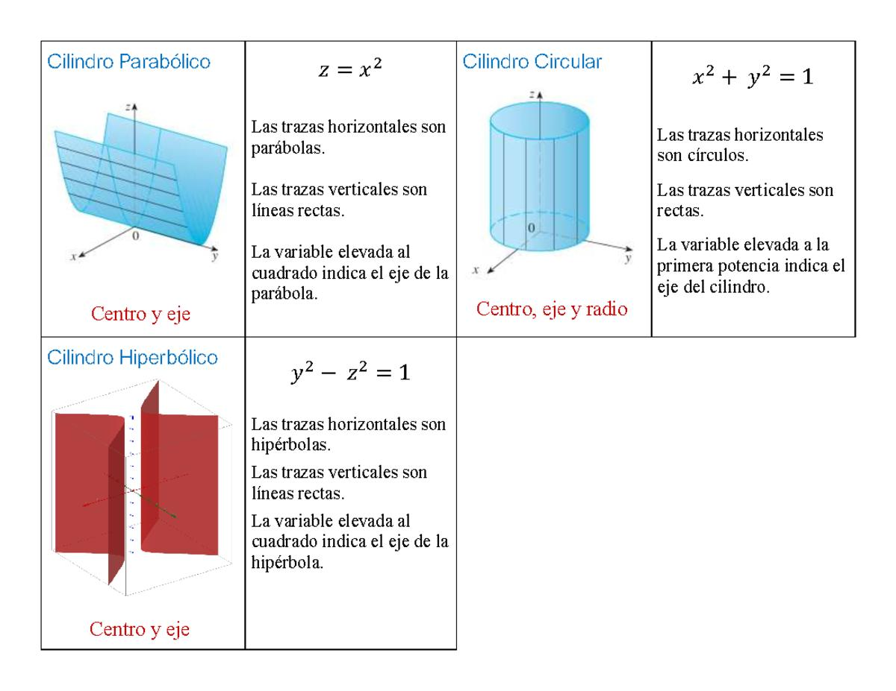

Mathematical Representation
# Source: AI Source: Provided by: [Data Path: Persons Table -> ID Column: 1, Name_En Column: Motasem Essam] -> From: [ChatGPT] on [7/20/2026]
A general cylindrical surface can be represented parametrically.
Let the directrix be represented by
$$c\left(u\right)$$
and let
$$d$$
be a fixed direction vector.
Then the cylindrical surface can be written as
$$\boxed{r\left(u , v\right)=c\left(u\right)+vd}$$
where:
- $u$determines a point on the directrix.
- $v$determines the position along a generator.
- $c\left(u\right)$is the directrix.
- $d$is the common generator direction.
This equation expresses the fundamental idea of a general cylindrical surface:
$$\boxed{\text{Surface}=\text{Directrix translated along a fixed direction}}$$

Example of a General Cylindrical Surface
# Source: AI Source: Provided by: [Data Path: Persons Table -> ID Column: 1, Name_En Column: Motasem Essam] -> From: [ChatGPT] on [7/20/2026]
Consider the directrix
$$x^{2}+y^{2}=4$$
in the $xy$-plane.
Extending this curve parallel to the $z$-axis gives
$$\boxed{x^{2}+y^{2}=4}$$
with $z$unrestricted.
This produces a circular cylindrical surface.
However, consider the directrix
$$x^{2}+y^{2}/4=1.$$
Extending this ellipse parallel to the $z$-axis gives an elliptical cylindrical surface.
Thus, the circular cylinder is only one special case of a general cylindrical surface.

Types of General Cylindrical Surfaces
# Source: AI Source: Provided by: [Data Path: Persons Table -> ID Column: 1, Name_En Column: Motasem Essam] -> From: [ChatGPT] on [7/20/2026]
General cylindrical surfaces can be classified according to the shape of their directrix.

Directrix | Resulting Surface
Circle | Circular cylindrical surface
Ellipse | Elliptical cylindrical surface
Parabola | Parabolic cylindrical surface
Hyperbola | Hyperbolic cylindrical surface
Other plane curve | General cylindrical surface
Therefore:
$$\boxed{\text{Circular Cylindrical Surface}⊂\text{General Cylindrical Surface}}$$
when "general cylindrical surface" is being used as the broad category.

Important Classification
# Source: AI Source: Provided by: [Data Path: Persons Table -> ID Column: 1, Name_En Column: Motasem Essam] -> From: [ChatGPT] on [7/20/2026]
There are two different characteristics that should not be confused:
Classification by Directrix
This describes the shape of the cross-section.
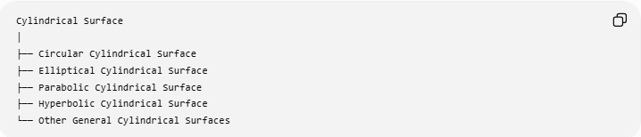
Cylindrical Surface
│
├── Circular Cylindrical Surface
├── Elliptical Cylindrical Surface
├── Parabolic Cylindrical Surface
├── Hyperbolic Cylindrical Surface
└── Other General Cylindrical Surfaces
Classification by Orientation
This describes the direction of the generators relative to the directrix plane.
For circular cylinders:
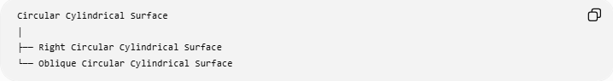
Circular Cylindrical Surface
│
├── Right Circular Cylindrical Surface
└── Oblique Circular Cylindrical Surface
Therefore, circular and right/oblique describe different properties.

General Cylindrical Surface vs Circular Cylindrical Surface
# Source: AI Source: Provided by: [Data Path: Persons Table -> ID Column: 1, Name_En Column: Motasem Essam] -> From: [ChatGPT] on [7/20/2026]
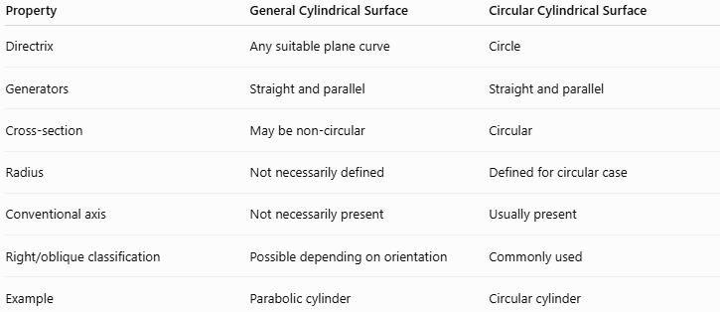
Property | General Cylindrical Surface | Circular Cylindrical Surface
Directrix | Any suitable plane curve | Circle
Generators | Straight and parallel | Straight and parallel
Cross-section | May be non-circular | Circular
Radius | Not necessarily defined | Defined for circular case
Conventional axis | Not necessarily present | Usually present
Right/oblique classification | Possible depending on orientation | Commonly used
Example | Parabolic cylinder | Circular cylinder

General Properties
# Source: AI Source: Provided by: [Data Path: Persons Table -> ID Column: 1, Name_En Column: Motasem Essam] -> From: [ChatGPT] on [7/20/2026]
A general cylindrical surface has the following properties:
1. Generators are parallel
All generators have the same direction.
$$\boxed{d=\text{constant}}$$
2. Generators are straight lines
Each generator is a straight line.
3. The directrix determines the shape
Changing the directrix changes the cross-sectional shape of the cylindrical surface.
4. The surface is generally curved
The directrix may curve, producing a curved surface.
5. No vertex is required
Unlike a conical surface, the generators of a cylindrical surface do not meet at one point.
6. Circular symmetry is not required
A general cylindrical surface does not necessarily have circular symmetry.
7. The surface may be open or bounded
A finite portion of the cylindrical surface has boundary curves. If appropriate end surfaces are added, a closed solid can be formed.

Open and Closed Forms
# Source: AI Source: Provided by: [Data Path: Persons Table -> ID Column: 1, Name_En Column: Motasem Essam] -> From: [ChatGPT] on [7/20/2026]
The cylindrical surface itself should be distinguished from the corresponding solid.
For example, a finite circular cylindrical lateral surface has two circular boundary curves:

┌───────────┐
/ \
| |
| |
| |
\ /
└───────────┘
The lateral surface alone is open.
If two end surfaces are added, the resulting boundary becomes a closed surface.
The same idea applies to a general cylindrical surface.

Surface Area
# Source: AI Source: Provided by: [Data Path: Persons Table -> ID Column: 1, Name_En Column: Motasem Essam] -> From: [ChatGPT] on [7/20/2026]
There is no single universal elementary surface-area formula for every general cylindrical surface.
The area depends on:
- The shape of the directrix.
- The direction of the generators.
- The length of the generators.
- The geometry of the finite portion being considered.
For a right circular cylindrical surface, the familiar formula is
$$A=2πrh.$$
But this formula cannot be automatically applied to every general cylindrical surface.
For a general parametric surface
$$r\left(u , v\right)=c\left(u\right)+vd,$$
surface area can be calculated using
$$A=\int{∫}∣\frac{∂r}{∂u}×\frac{∂r}{∂v}∣ du dv.$$
This is the more general mathematical treatment.

Example 1 – Elliptical Cylindrical Surface
# Source: AI Source: Provided by: [Data Path: Persons Table -> ID Column: 1, Name_En Column: Motasem Essam] -> From: [ChatGPT] on [7/20/2026]
Consider the ellipse
$$\frac{x^{2}}{9}+\frac{y^{2}}{4}=1.$$
Extend it parallel to the $z$-axis.
The resulting surface is
$$\boxed{\frac{x^{2}}{9}+\frac{y^{2}}{4}=1}.$$
This is an elliptical cylindrical surface.
The semi-axes of the ellipse are
$$a=3, b=2.$$
Unlike a circular cylinder, there is no single radius $r$describing the cross-section.

Example 2 – Parabolic Cylindrical Surface
# Source: AI Source: Provided by: [Data Path: Persons Table -> ID Column: 1, Name_En Column: Motasem Essam] -> From: [ChatGPT] on [7/20/2026]
Consider the parabola
$$y=x^{2}.$$
Extend it parallel to the $z$-axis.
The resulting cylindrical surface is
$$\boxed{y=x^{2}}.$$
This is a parabolic cylindrical surface.
Notice that $z$does not appear in the equation. The parabola is extended indefinitely in the $z$-direction.

Example 3 – General Parametric Cylinder
# Source: AI Source: Provided by: [Data Path: Persons Table -> ID Column: 1, Name_En Column: Motasem Essam] -> From: [ChatGPT] on [7/20/2026]
Suppose a directrix is
$$c\left(u\right)=\left(\cos{u} , , 2\sin{u} 0\right)$$
and the generators have direction
$$d=\left(1 , 0 , 1\right).$$
Then
$$r\left(u , v\right)=\left(\cos{u} , , 2\sin{u} 0\right)+v\left(1 , 0 , 1\right).$$
Therefore,
$$\boxed{r\left(u , v\right)=\left(\cos{u} , + , v 2\sin{u} v\right)}$$
represents an oblique elliptical cylindrical surface.

General Cylindrical Surface vs Conical Surface
# Source: AI Source: Provided by: [Data Path: Persons Table -> ID Column: 1, Name_En Column: Motasem Essam] -> From: [ChatGPT] on [7/20/2026]
These surfaces are related because both can be generated using straight lines.
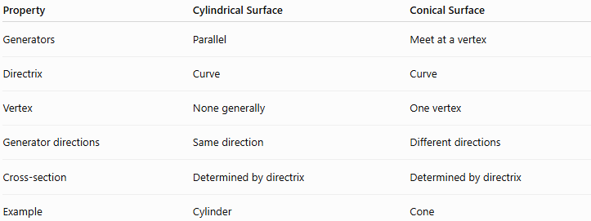
Property | Cylindrical Surface | Conical Surface
Generators | Parallel | Meet at a vertex
Directrix | Curve | Curve
Vertex | None generally | One vertex
Generator directions | Same direction | Different directions
Cross-section | Determined by directrix | Determined by directrix
Example | Cylinder | Cone
The key distinction is:
$$\boxed{\text{Cylinder: parallel generators}}$$
while
$$\boxed{\text{Cone: generators meet at a vertex}}$$

Relationship with Circular Cylindrical Surface
# Source: AI Source: Provided by: [Data Path: Persons Table -> ID Column: 1, Name_En Column: Motasem Essam] -> From: [ChatGPT] on [7/20/2026]
The Circular Cylindrical Surface is a special case of the general cylindrical surface.
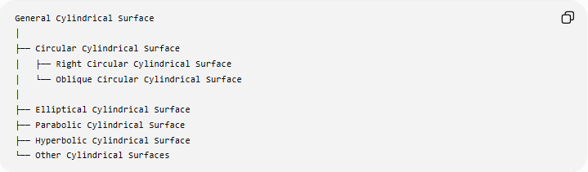
General Cylindrical Surface
│
├── Circular Cylindrical Surface
│ ├── Right Circular Cylindrical Surface
│ └── Oblique Circular Cylindrical Surface
│
├── Elliptical Cylindrical Surface
├── Parabolic Cylindrical Surface
├── Hyperbolic Cylindrical Surface
└── Other Cylindrical Surfaces
This is a useful hierarchy for your knowledge base.

Real-World Applications
# Source: AI Source: Provided by: [Data Path: Persons Table -> ID Column: 1, Name_En Column: Motasem Essam] -> From: [ChatGPT] on [7/20/2026]
General cylindrical surfaces are useful in:
- Engineering structures
- Pipes with non-circular cross-sections
- Aircraft and aerospace structures
- Architectural roofs
- Mechanical components
- Industrial ducts
- Structural beams
- Mathematical modeling
- Computer-aided design (CAD)
- Surface modeling
- Computational geometry
For example, an elliptical duct can be modeled using an elliptical cylindrical surface rather than a circular one.

Advantages
# Source: AI Source: Provided by: [Data Path: Persons Table -> ID Column: 1, Name_En Column: Motasem Essam] -> From: [ChatGPT] on [7/20/2026]
- Provides a general framework for many cylindrical shapes.
- Can represent non-circular cross-sections.
- Useful in analytic geometry and calculus.
- Easily represented parametrically.
- Useful for engineering and CAD modeling.
- Includes circular cylindrical surfaces as special cases.

Limitations
# Source: AI Source: Provided by: [Data Path: Persons Table -> ID Column: 1, Name_En Column: Motasem Essam] -> From: [ChatGPT] on [7/20/2026]
- There is no single simple area formula for every general cylindrical surface.
- A conventional radius may not exist.
- A conventional axis may not exist.
- The geometry can become considerably more complicated when the directrix is irregular.
- Surface-area calculations may require calculus.

Key Points
# Source: AI Source: Provided by: [Data Path: Persons Table -> ID Column: 1, Name_En Column: Motasem Essam] -> From: [ChatGPT] on [7/20/2026]
- A General Cylindrical Surface is generated by parallel straight lines called generators.
- The generators follow a fixed curve called the directrix.
- The directrix does not have to be a circle.
- The general parametric form is
$$\boxed{r\left(u , v\right)=c\left(u\right)+vd}$$
- Circular, elliptical, parabolic, and hyperbolic cylindrical surfaces can all be treated within the general framework.
- A circular cylindrical surface is a special case of a general cylindrical surface.
- Right and oblique describe the orientation of the generators, while circular, elliptical, parabolic, etc. describe the directrix.
- Unlike a cone, the generators of a cylindrical surface are parallel.
- General cylindrical surface area generally requires more information and may require calculus.

